**Lab - The Tableau Interface**

Shaun Pritchard

Rasmussen College

QMB3300

Jerome Olorunmaiye

May 18, 2020

**Lab - The Tableau Interface**

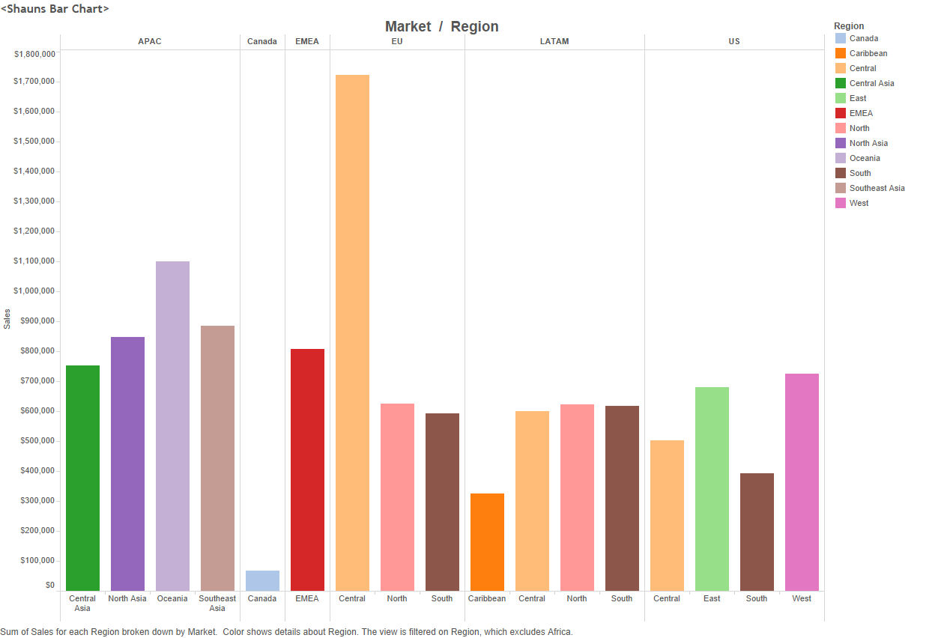

There was no Eastern Asia only Southeaster Asia

